Project Report Format
AI Travel Itinerary Generator using Streamlit & Gemini API

1) INTRODUCTION

1.1 Project Overview
The AI Travel Itinerary Generator is a Generative AI-based web application that automatically creates personalized travel plans based on user inputs such as destination, number of days, nights, and interests. The system uses a Large Language Model through Gemini API and provides structured, day-wise travel itineraries instantly through a Streamlit interface.

1.2 Purpose
Travel planning is often time-consuming and confusing due to scattered information. This project aims to simplify travel planning by generating customized, structured itineraries using AI, reducing manual effort and improving decision quality.

2) IDEATION PHASE

2.1 Problem Statement
Travel planning is time-consuming and requires browsing multiple websites for destinations, food, shopping, and activities. Users often feel confused and uncertain about trip structure. There is a need for an AI-based system that generates instant, personalized, day-wise travel itineraries.

2.2 Empathy Map Canvas
Think & Feel
- Wants smooth trip planning
- Feels overwhelmed by too many options
- Wants personalized suggestions
- Worried about missing important places
See
- Multiple blogs and travel sites
- Conflicting recommendations
- Social media travel reels
- Package advertisements
Hear
- Friends suggesting different places
- Influencer travel tips
- Family safety advice
Say & Do
- Searches destinations online
- Compares multiple sources
- Saves notes and screenshots
Pain
- Too much scattered information
- No clear day-wise plan
- Planning fatigue

Gain
- Instant AI itinerary
- Personalized plan
- Saves time
- More confidence in trip planning

2.3 Brainstorming
Ideas considered:
- Static travel guide app
- Blog aggregator
- Rule-based itinerary builder
- AI-powered itinerary generator (Selected)
Reason: Dynamic, scalable, intelligent, and personalized.

3) REQUIREMENT ANALYSIS

3.1 Customer Journey Map
- User opens app
- Enters destination + days + interests
- Clicks generate
- AI processes prompt
- Returns structured itinerary
- User reviews & uses plan
3.2 Solution Requirements
- User input form
- AI text generation
- Prompt engineering
- Streamlit UI
- API integration
- Error handling

3.3 Data Flow Diagram

User → Streamlit UI → Prompt Builder → Gemini API → AI Response → Itinerary Display
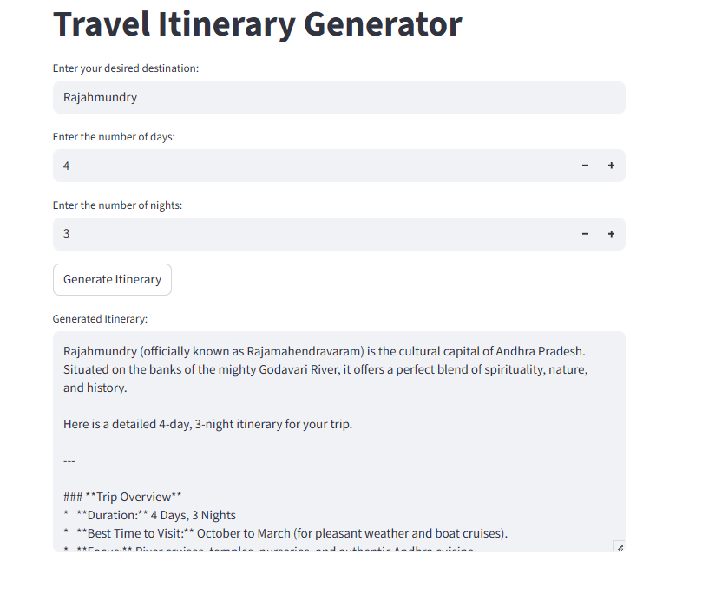

3.4 Technology Stack
Frontend: Streamlit
Backend Logic: Python
AI Model: Gemini API
Libraries: google-generativeai, streamlit
Environment: Python 3.x

4) PROJECT DESIGN

4.1 Problem–Solution Fit
Problem | Solution
Manual trip planning | AI itinerary generation
Scattered info | Structured day-wise plan
Time consuming | Instant output

4.2 Proposed Solution
An AI-powered web application that generates personalized travel itineraries using user inputs and generative AI models via API.

4.3 Solution Architecture
User Input → Streamlit UI → Python Prompt Logic → Gemini API → Generated Itinerary → Display

5) PROJECT PLANNING & SCHEDULING

Sprint Plan

Sprint 1 — Core Setup (12 points)
- Project setup
- API integration
- Prompt design
- Basic UI

Sprint 2 — Features (20 points)
- Itinerary generator
- UI enhancement
- Error handling
- Testing

Velocity Calculation
Total Story Points = 32
Sprints = 2
Velocity = 16 story points per sprint

6) FUNCTIONAL & PERFORMANCE TESTING

Functional Tests
Test Case | Scenario | Result
Valid input | Generate itinerary | Pass
Invalid input | Error shown | Pass
API call | Response received | Pass

Performance
- Average generation time: 2–4 seconds
- Stable under repeated requests

7) RESULTS
- AI generated structured itineraries successfully
- Supports multiple destinations
- Personalized output
- Fast response

8) ADVANTAGES & DISADVANTAGES

Advantages
- Instant itinerary
- Personalized
- Saves time
- Easy UI
- Scalable

Disadvantages
- Depends on API
- Needs internet
- AI output may vary

9) CONCLUSION
The AI Travel Itinerary Generator successfully demonstrates how Generative AI can automate and personalize travel planning. The system reduces manual effort and provides structured travel plans instantly using modern AI APIs.

10) FUTURE SCOPE
- Hotel recommendations
- Budget planner
- Map integration
- Booking links
- Multi-language support
- Voice input

11) APPENDIX

Source Code
GitHub Repository:
https://github.com/prathyusha011/ai-travel-itinerary-generator

Dataset
Not applicable — AI generated dynamic content.

Demo Video
https://drive.google.com/file/d/1XRoTI-f47B9X7eD1vj6x2d6gHhjXFD4x/view?usp=sharing

Deployment Link (Optional)
https://ai-travel-itinerary-generator-0zk8.onrender.com

